**Checking for any duplicates:**

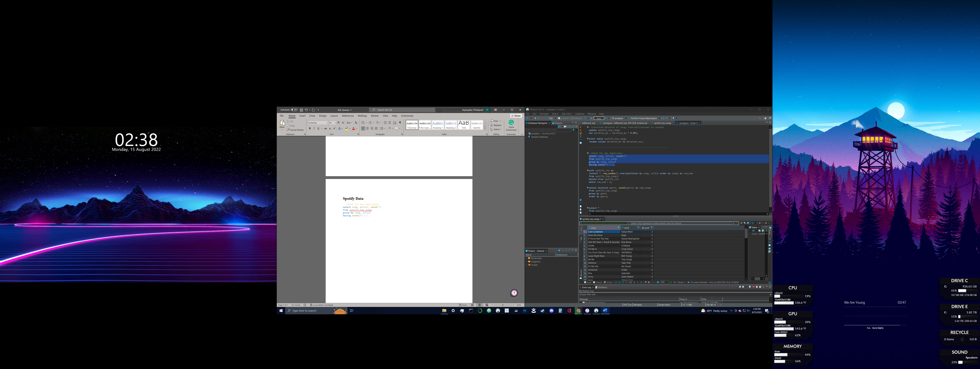

**Check to see which genres were listened to the most:**

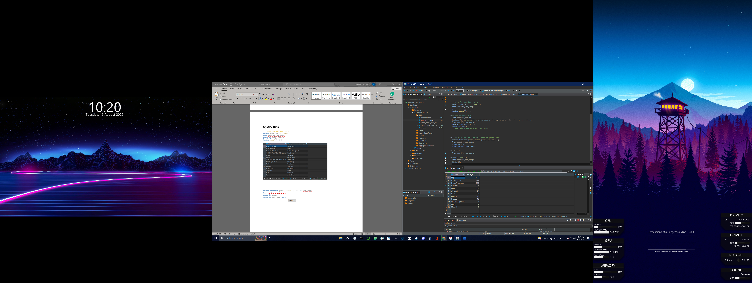

**Top 20 most popular songs and their respective BPM:**

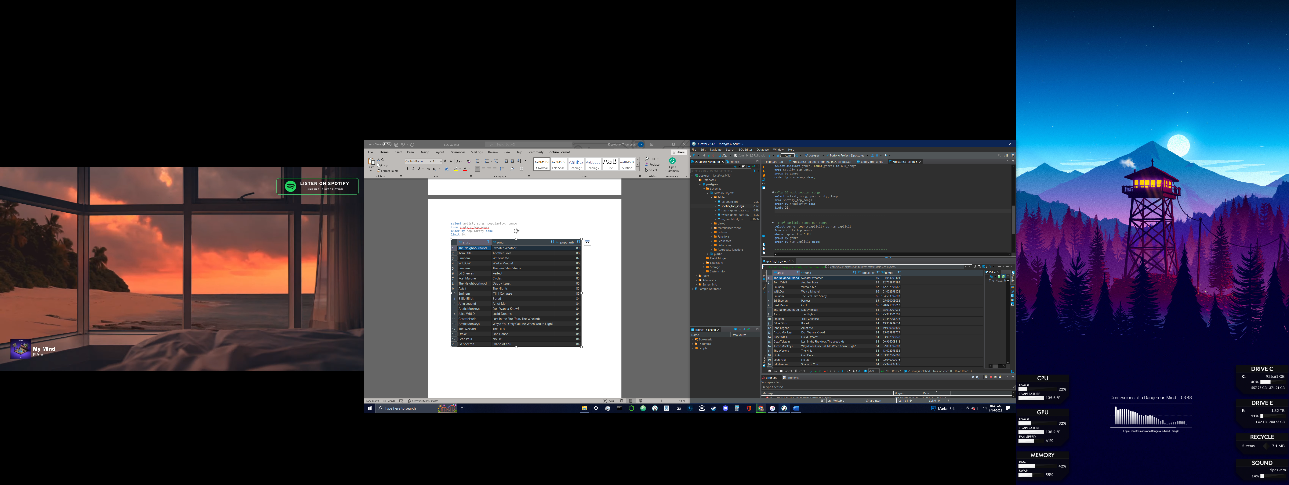

**# of explicit songs per genre:**

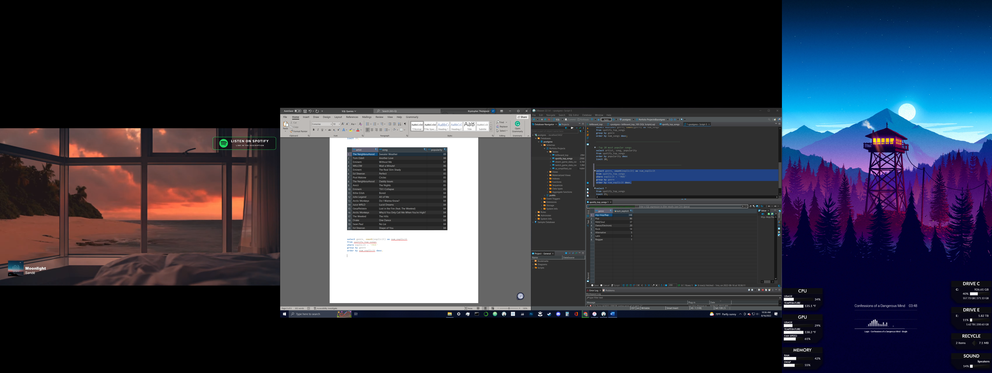

**# of songs in each genre grouped by year, as well as the total # of songs within each year:**

